Copyright for test papers and marking guides remains with *West Australian Test Papers.*

Test papers may only be reproduced within the purchasing school according to the advertised Conditions of Sale.

Test papers should be withdrawn after use and stored securely in the school until Friday June 16th 2017.



**MATHEMATICS**

**SPECIALIST**

**UNIT 3**

**Semester One**

**2017**

**SOLUTIONS**

***Calculator−free Solutions***

1. (a) ✓

✓

as required

(b) ✓

Using factorisation:

✓

✓

✓

OR using division of polynomials:

✓✓

|  |  |  |  |  |
| --- | --- | --- | --- | --- |
|  |  |  |  |  |
|  |  |  |  |  |
|  |  |  |  |  |
|  |  |  |  |  |
|  |  |  |  |  |
|  |  |  |  |  |

✓ [6]

2. (a)

with ✓

with ✓

hence,

✓✓

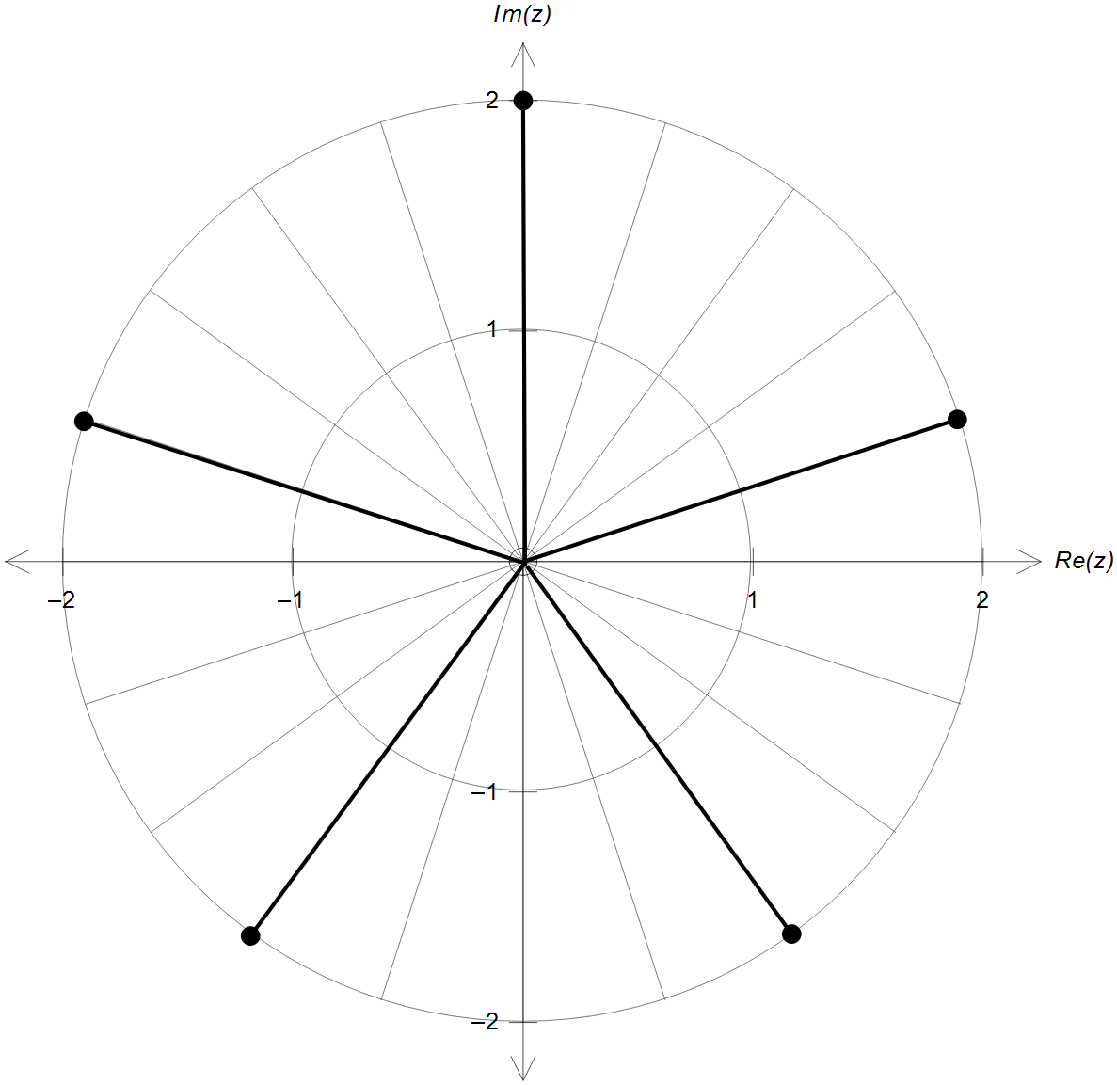2. (b)

✓ magnitude = 2

✓ radians apart

[6]

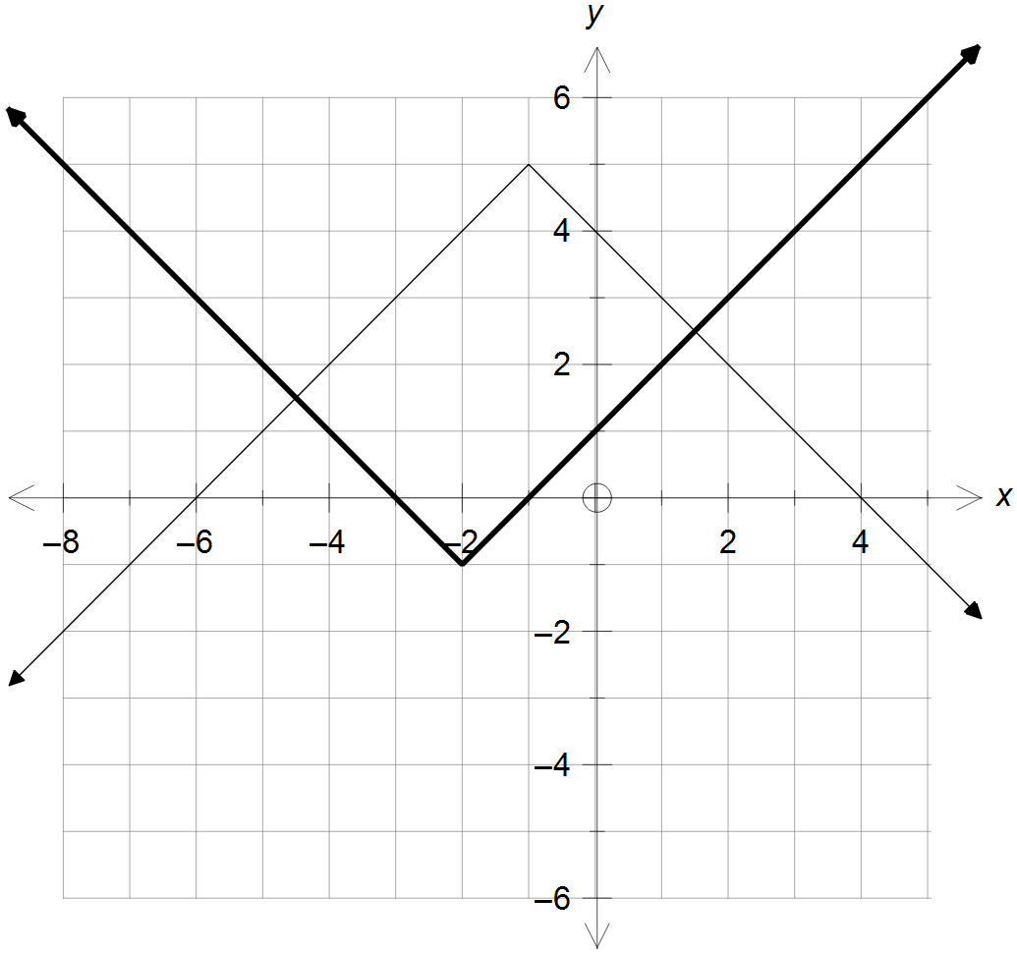

3. (a)

✓ correct x position

✓ correct y position

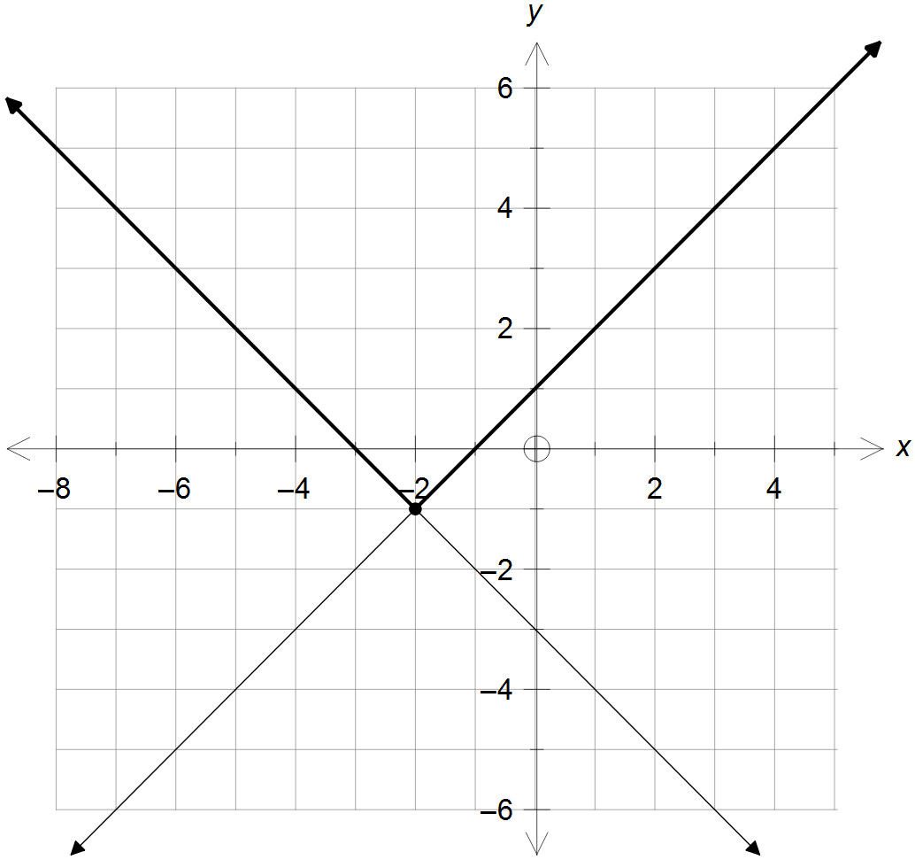

(b) (i)

and ✓✓

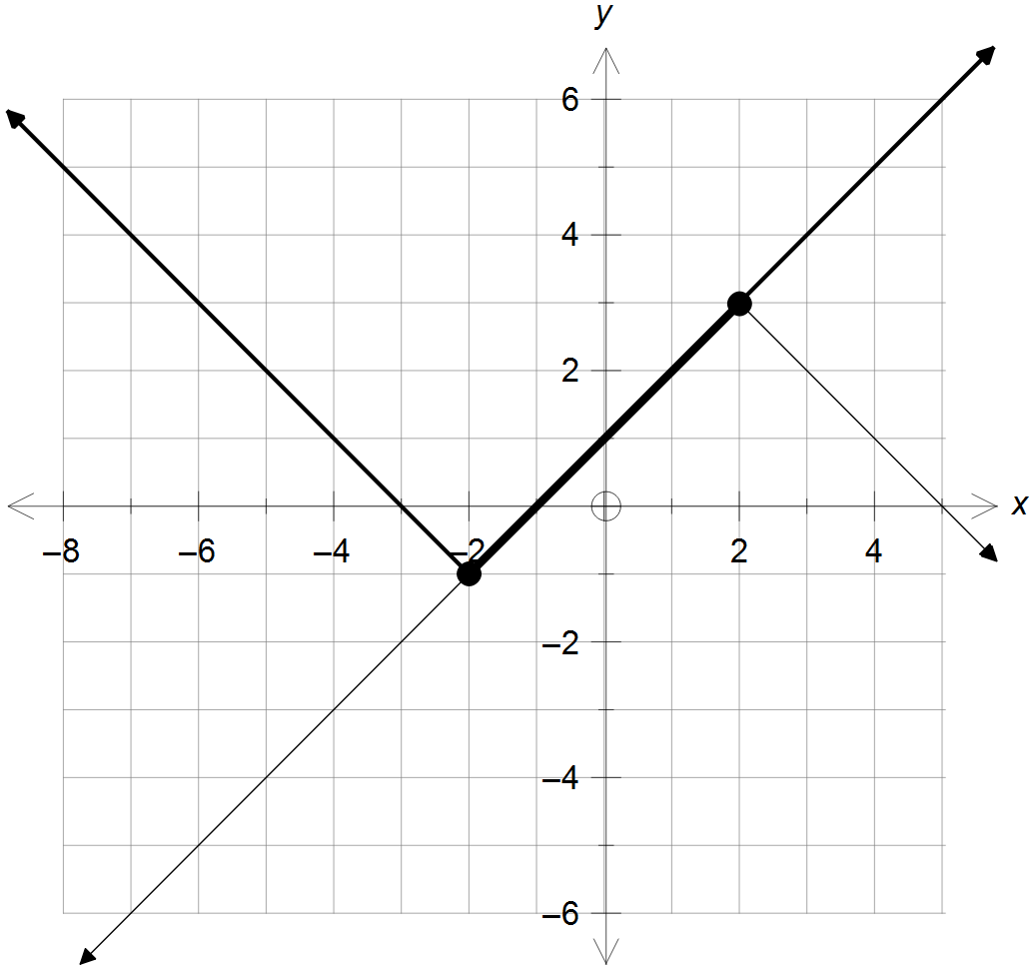3. (b) (ii)

and ✓✓ [2]

4. (a) with

✓

and ✓✓

on its natural domain, hence ✓

will not be generated by the second

✓

(b)

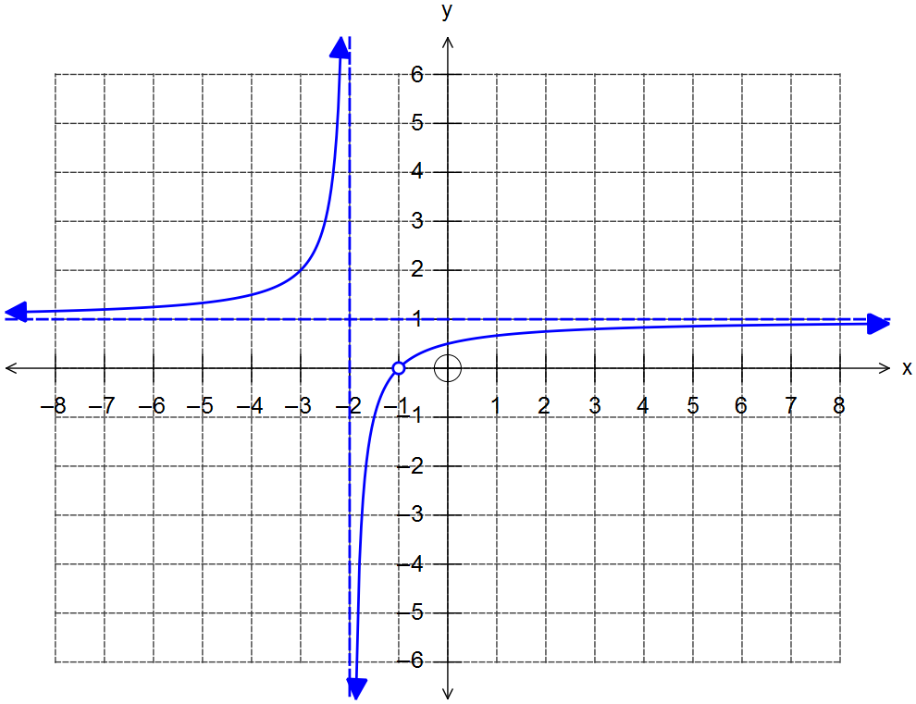 ✓

✓ asymptotes

x = -2 and y = 1

✓ discontinuity at

x = -1

✓ correct shape

4. (c)

✓

Domain ✓

Range ✓ [12]

5. (a) Cartesian equations of the planes:

Using matrices:

✓

✓

,

,

,

Unique solution: ✓

(b) Fully simplified matrix in terms of :

✓

✓

✓ [6]

(Algebraic manipulation and substitution is also acceptable)

6. (a) Midpoint between and is ✓✓

OR , centre = ✓✓

radius = units ✓

✓

(b)

✓✓

✓

✓ [8]

7. (a)

✓✓

(b) ✓

✓

✓

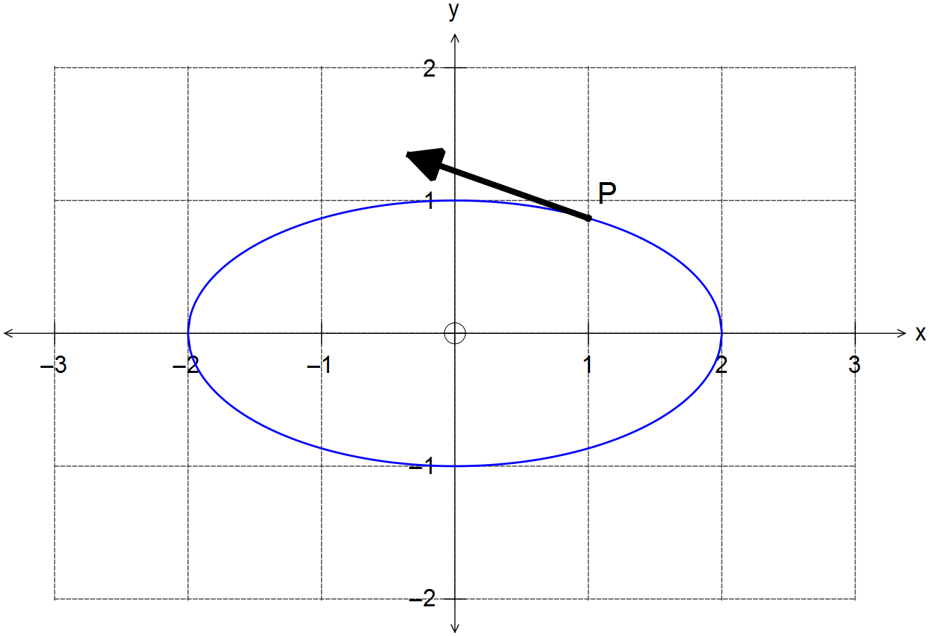

✓ [6]

***Calculator−Assumed Solutions***

8. (a) and ✓✓

(b)

✓

✓

✓✓ [6]

9. (a) ✓

✓

✓

✓

(b) Condition to stop:

✓

for *x* axis and for *y* axis ✓

Since there is no unique solution, the particle does

not come to a stop. ✓

(c) Motion parallel to *x* axis = no *y* axis velocity

seconds ✓✓

ms-1 ✓

✓ [11]

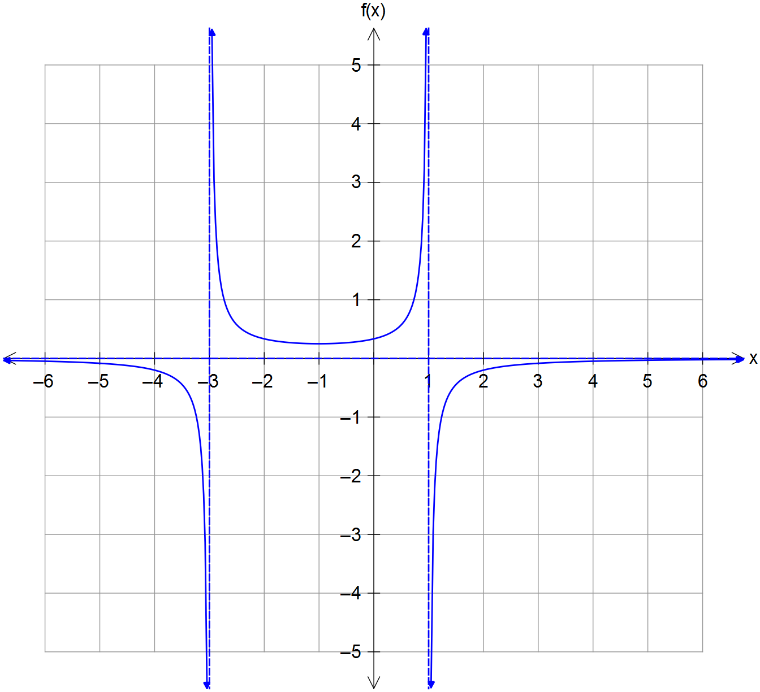10. (a)

✓ Vertical asymptotes

x = -3, x = 1

✓ Indicates y → 0-

as |x| → ∞

✓ Shows local min

at x = -1

✓ Correct curvature at

x = -3 and x = 1

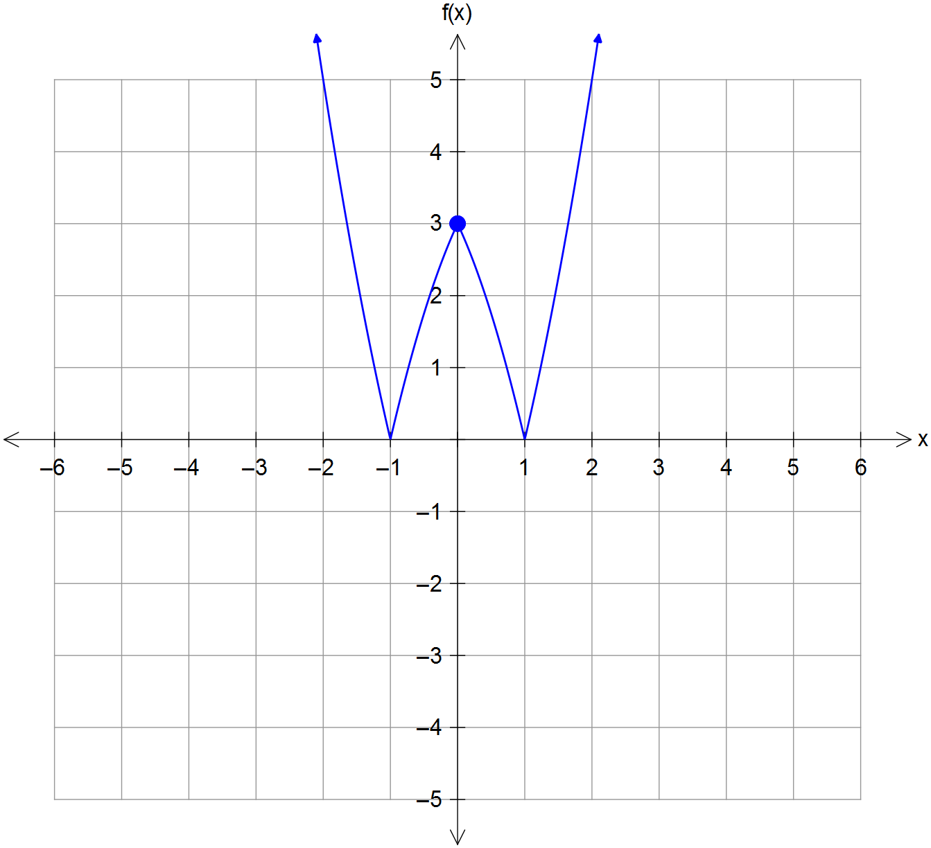 (b)

✓ Correct mirror image

over x axis

✓ Correct mirror image

over y axis

✓ Indicates points

(0,3),(-1,0) and (1,0)

(c) Function can be inverted about its turning point.

i.e., for ✓

Domain ✓

Range ✓ [10]

11. (a) At the xz plane y = 0. ✓

✓

circle centred at and radius units ✓✓

(b) Completing the squares of the original sphere:

✓

centre of sphere is

✓

✓

and hence ✓ [8]

12. (a)

✓✓✓

(b) (i) ✓

✓

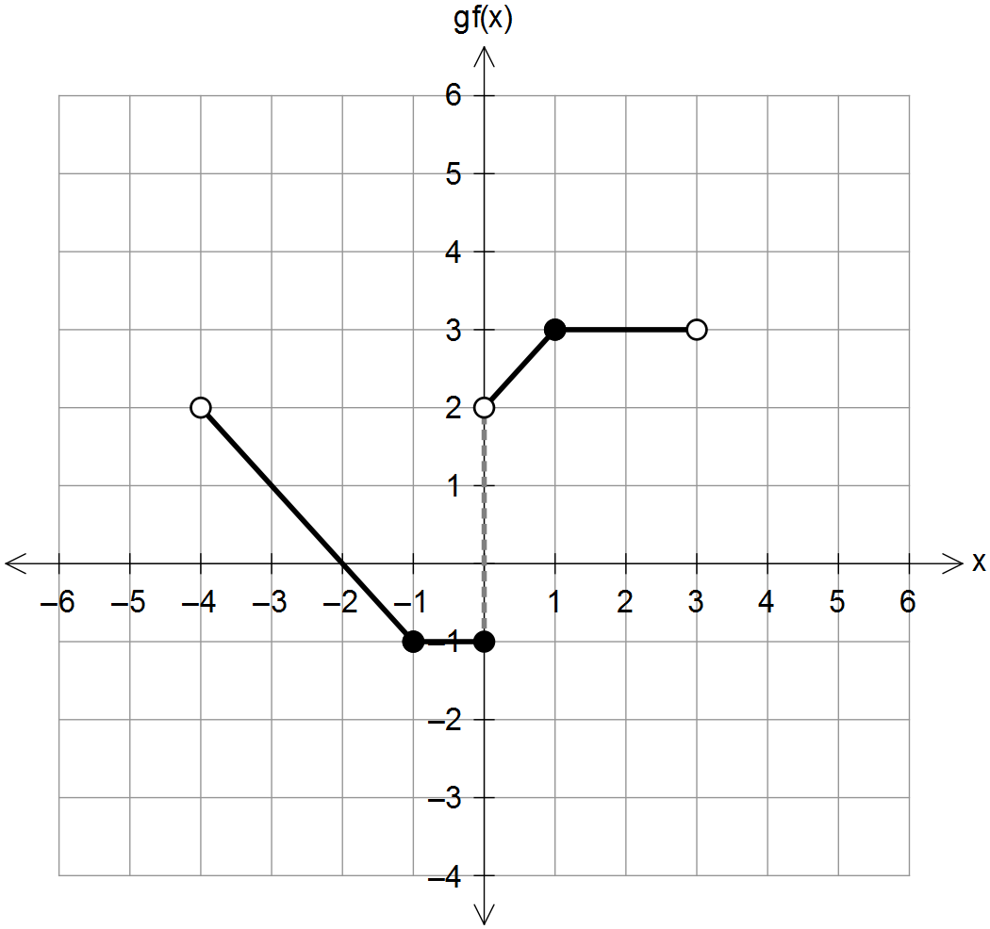

(ii)

✓ correct sections

✓ correct y-intersect

✓ correct discontinuities

[8]

13. (a) ✓✓✓

(b) region under spiral

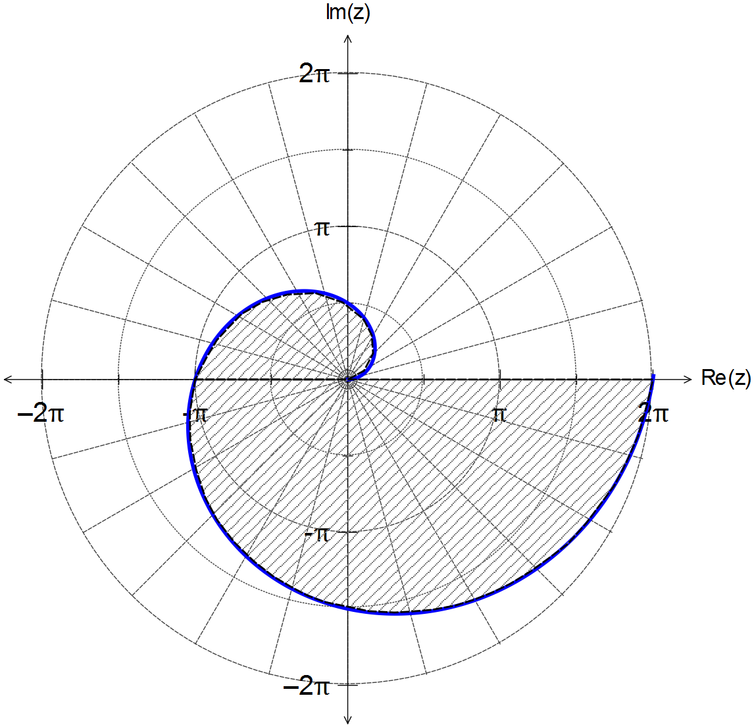

✓ spiral r = θ

✓ region under spiral

and x axis

(b) such that

CAS: ✓

✓

✓

circle centred at and radius ✓

with discontinuity at ✓

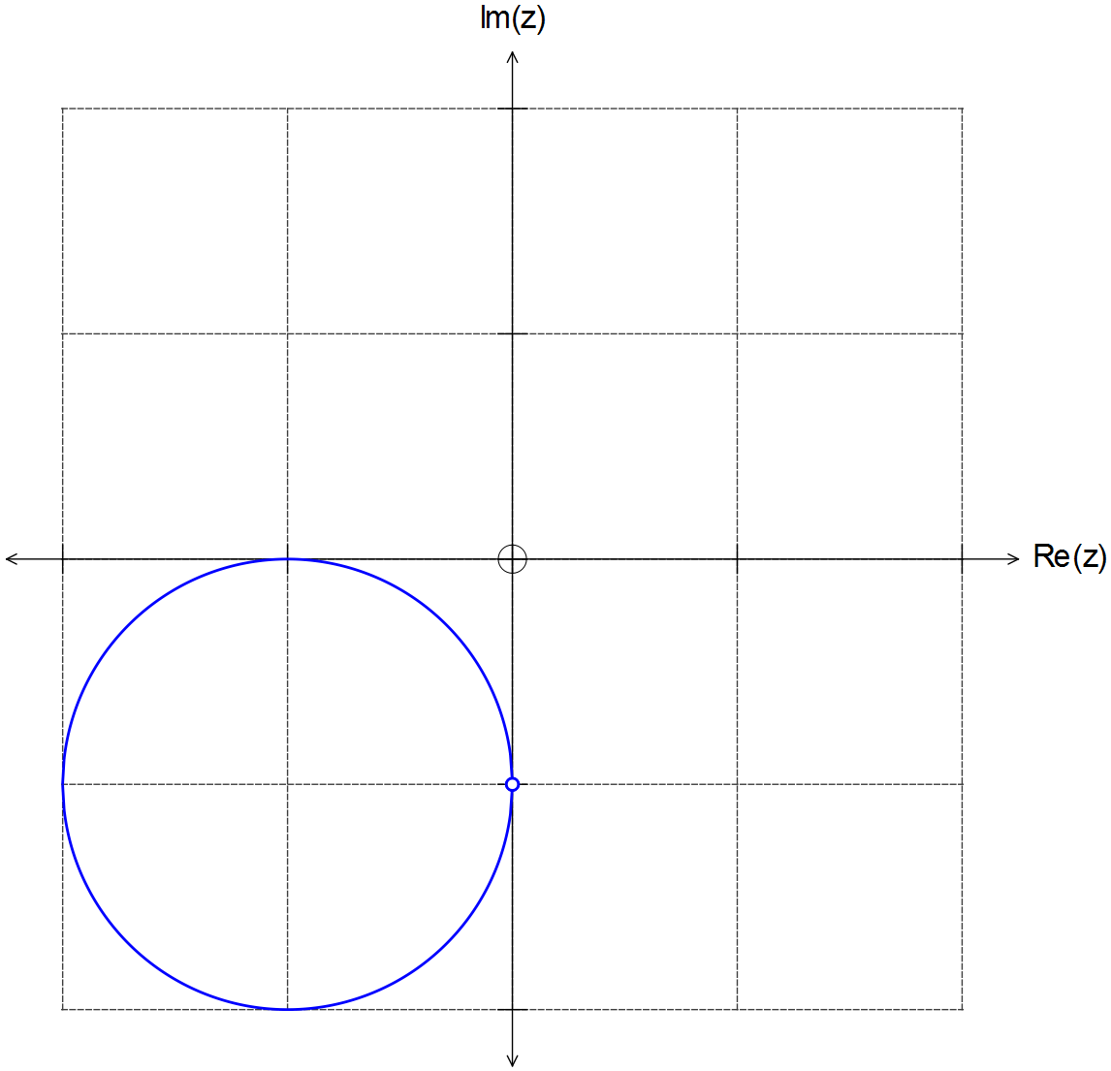

[10]

14. (a) height = vertical velocity × time = 90 × 4 = 360 m ✓

(b) Detonation at ✓

✓

direct distance = m ✓

time difference seconds ✓

(c) speed ms-1 ✓

projection vector onto xy plane ✓

✓

✓

(d) distance vector ✓

velocity ms-1 ✓ [11]

15. (a) (i)

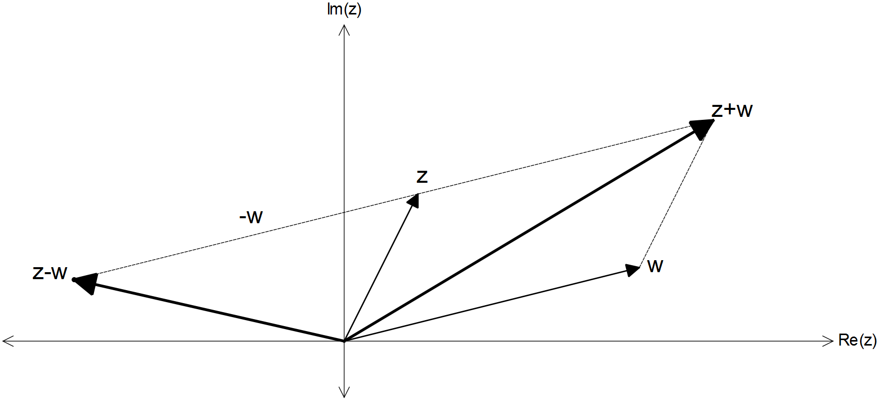

✓ z + w

✓ z – w in the

correct location

15. (a) (ii)

✓

✓

and hence ✓

if are treated as vectors, then ✓

and hence

(b) Let

✓

✓

✓✓

(c) (i)

and ✓✓

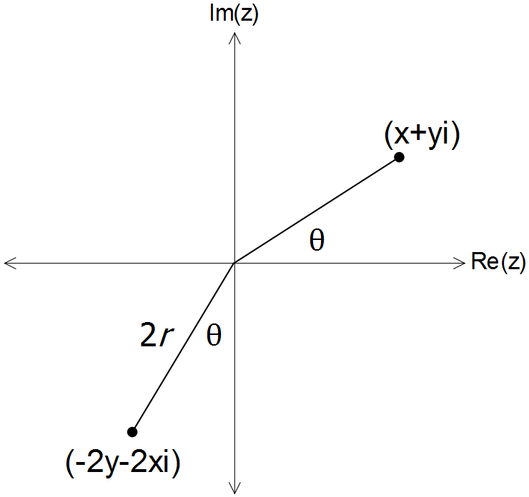

(ii)

✓

✓ [14]

16. (a) CAS ✓✓

(OR, using division of polynomials)

(b)

✓✓✓

✓✓ [7]

17. (a) By De Moivre’s theorem

✓

✓

✓

✓

✓

(b) Let , then ✓

when ✓

and

✓ [8]

18. (a) If the dot product is zero, then is perpendicular to

the plane normal to and . ✓✓

If the cross product is zero, then and are parallel ✓✓

(b) LHS

✓

✓

✓

RHS [7]